**Project Initialization and Planning Phase**

| Date | 15 August 2024 |
| --- | --- |
| Team ID | LTVIP2024TMID24802 |
| Project Name | ANALYSIS OF AMAZON CELL PHONE REVIEWS |
| Maximum Marks | 3 Marks |

**Define Problem Statements (Customer Problem Statement Template):**

The problem addressed by this project is the challenge of analyzing vast amounts of unstructured Amazon cell phone review data to accurately determine customer sentiment in real time. Understanding these sentiments is critical for businesses to gauge consumer satisfaction and preferences, but manual analysis is inefficient and prone to errors. This project aims to automate sentiment analysis, providing accurate, real-time insights through an LSTM model integrated into an interactive Flask-based UI.

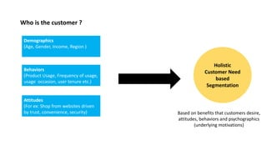

Reference: https://image.slidesharecdn.com/howtonailthecustomerproblemstatementbyamazonsrpm-210906201009/85/How-to-Nail-the-Customer-Problem-Statement-by-Amazon-Sr-PM-19-320.jpg

**Example:**

